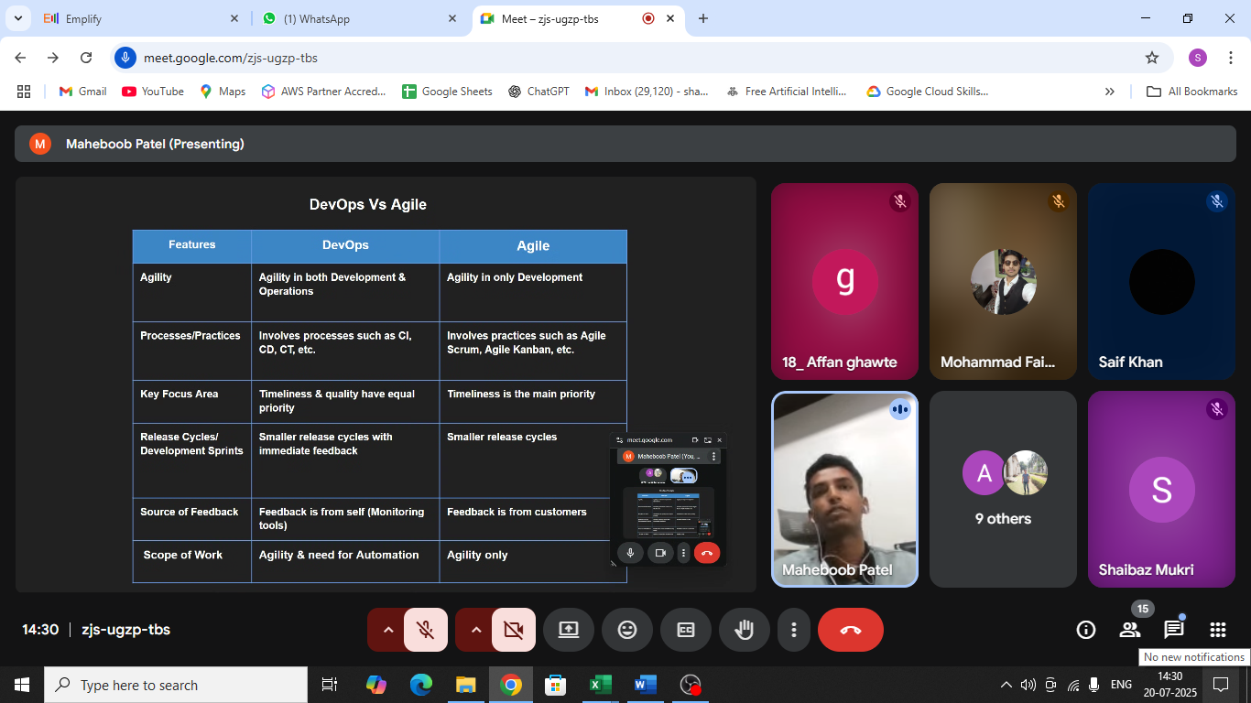

Deveops comes with Containerisation, CI/CD, Monitoring

Why the tool is used.

Whats the impact

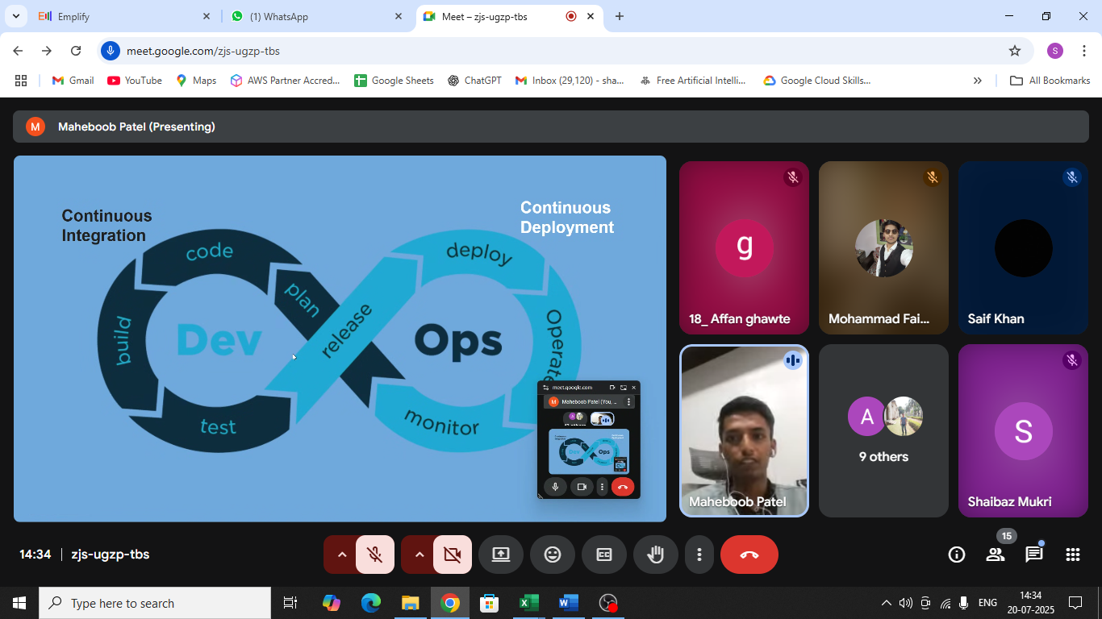

Best thing is to learn from scratch

Microservice – Making ur code modular level

If login gets failed still customer can order

Build phase

Kubernetes has two types

Openshift

Kubernetes native

Below codes are pushed into

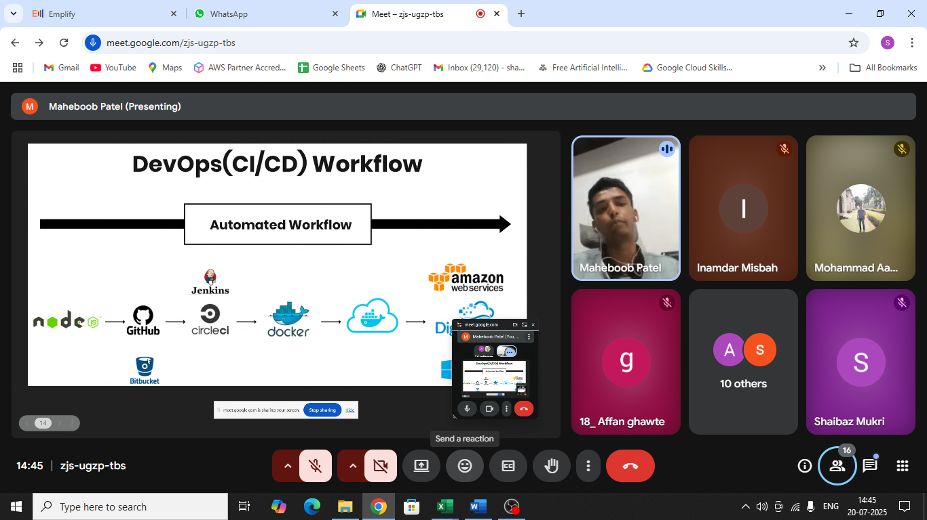

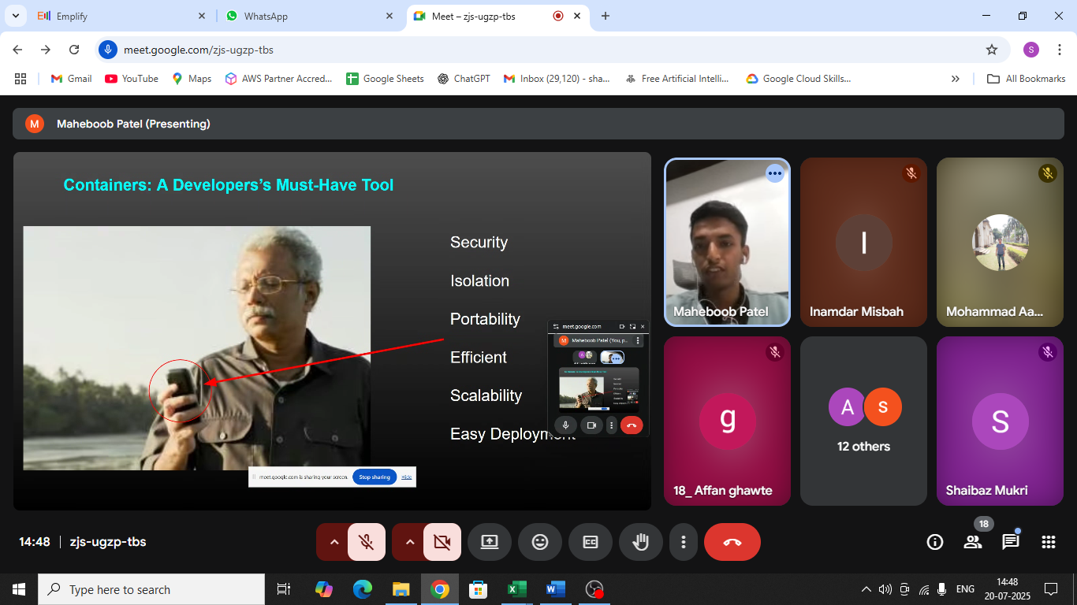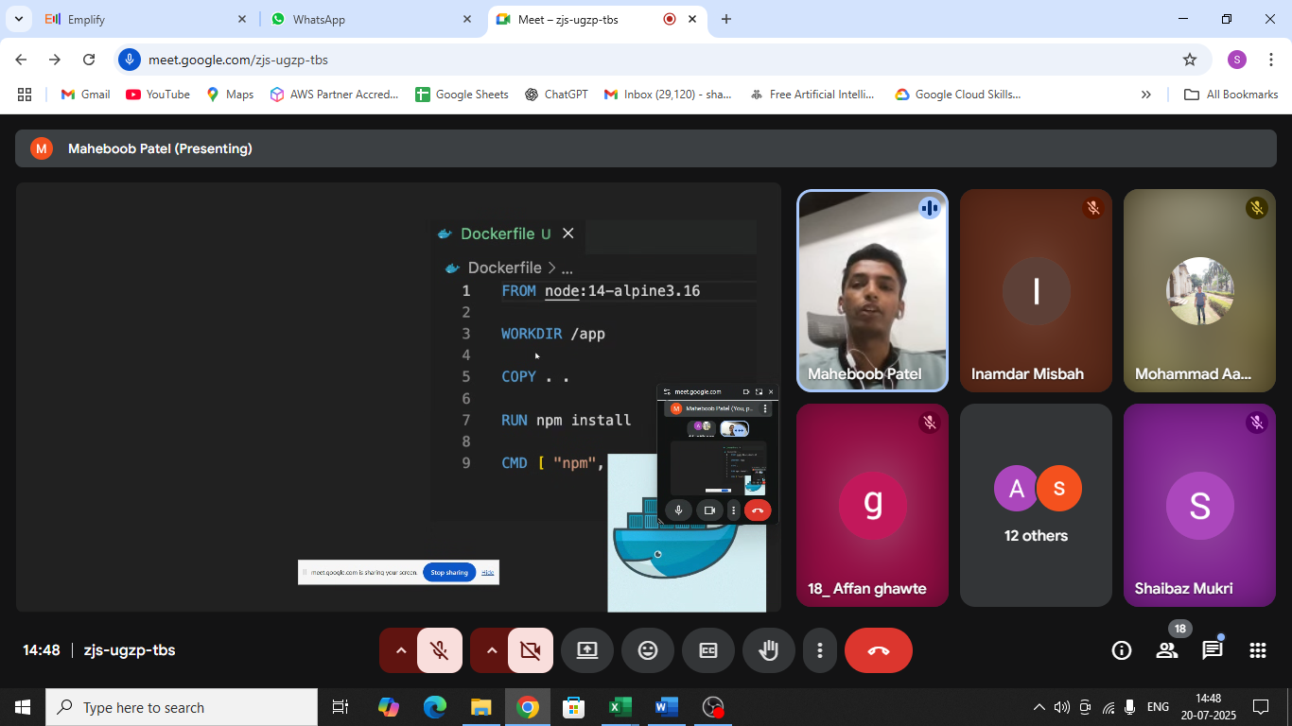

Containerisation

All packages are one

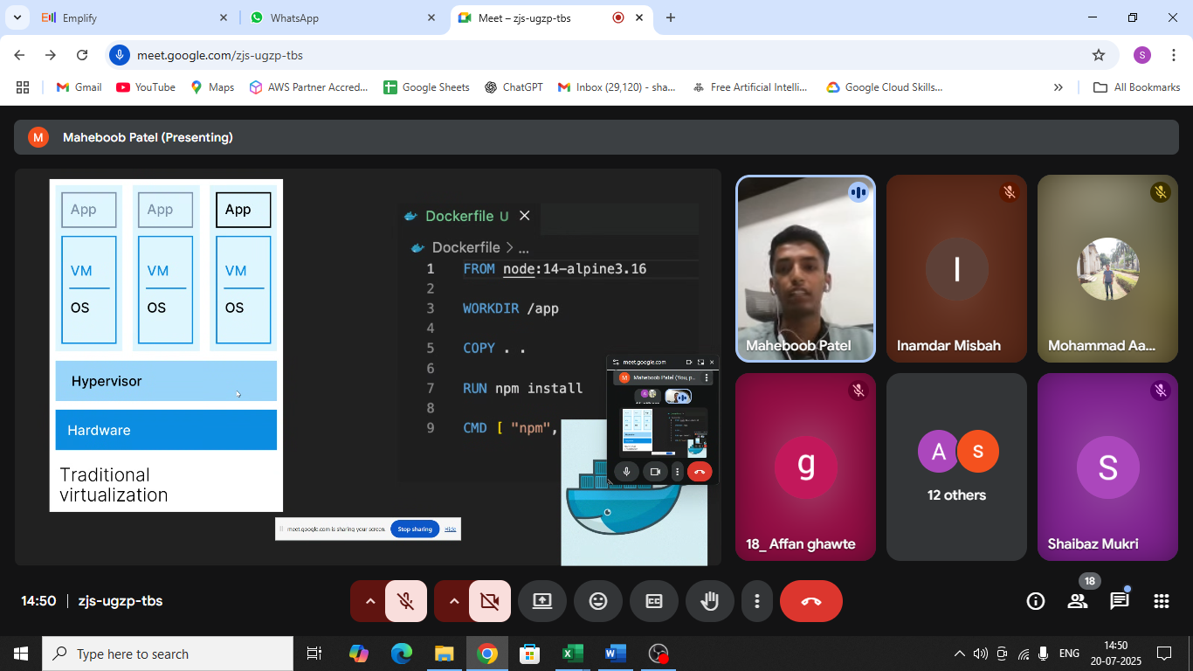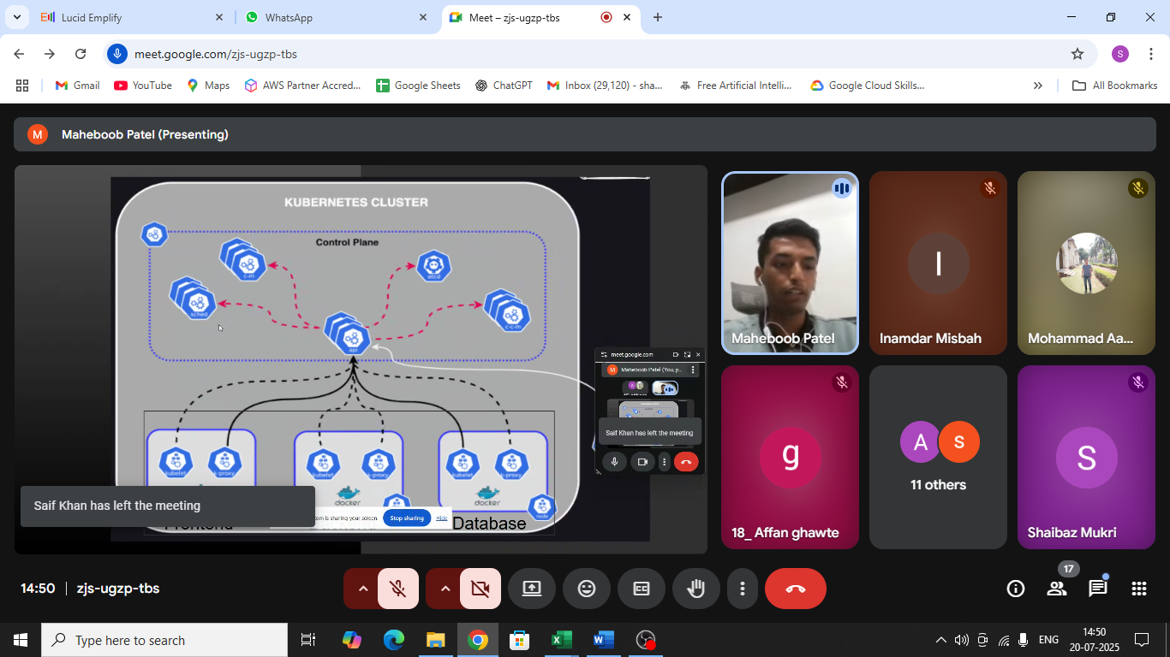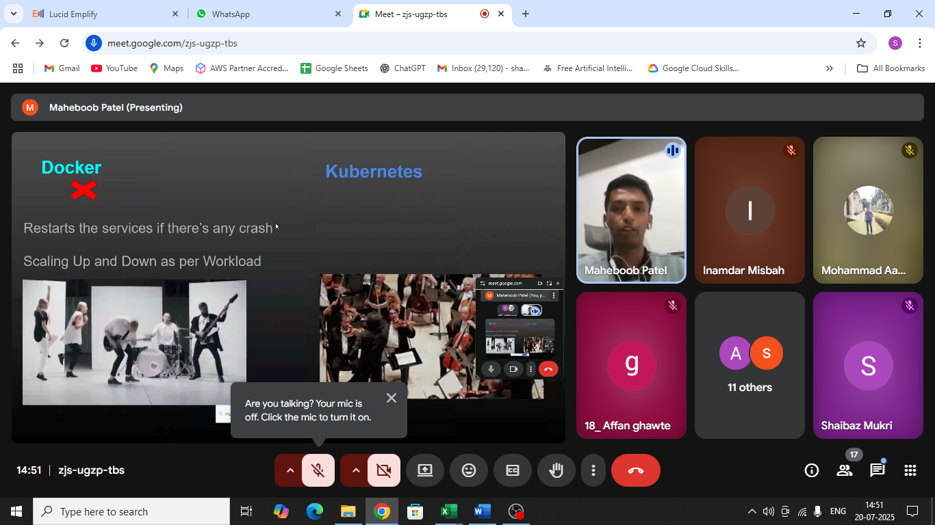

Horizontal scaling

Vertical Scaling

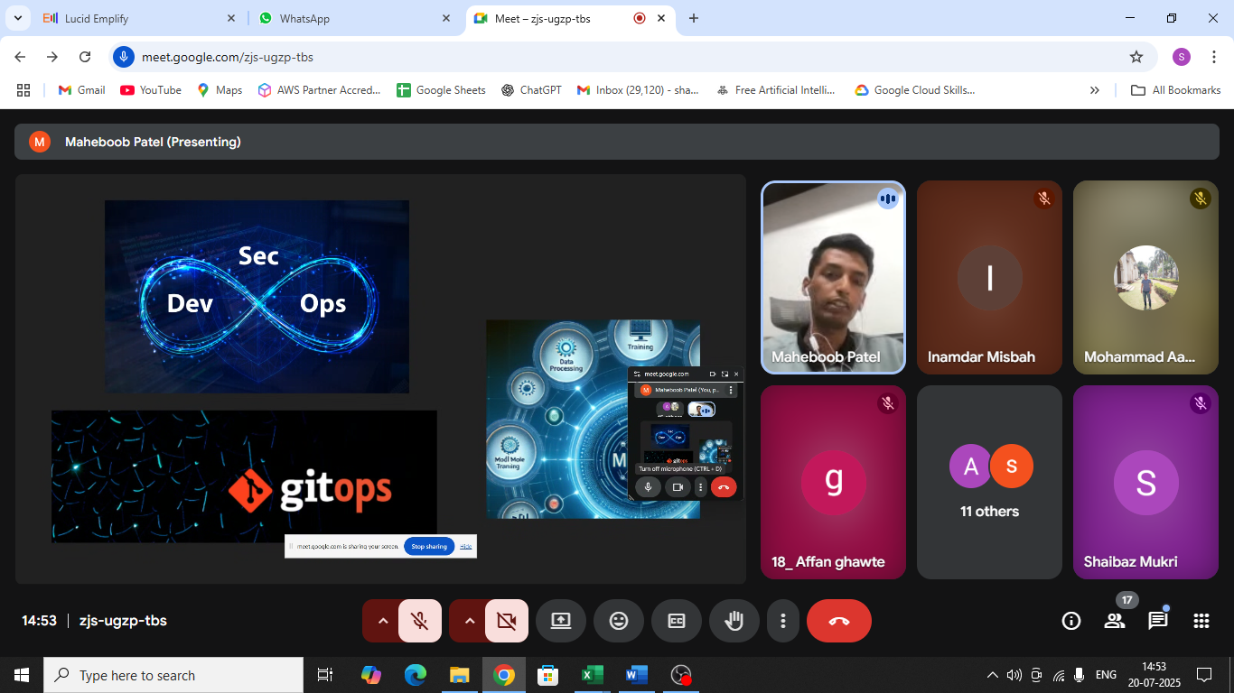

Github is used for repository

Gitops handle everything is

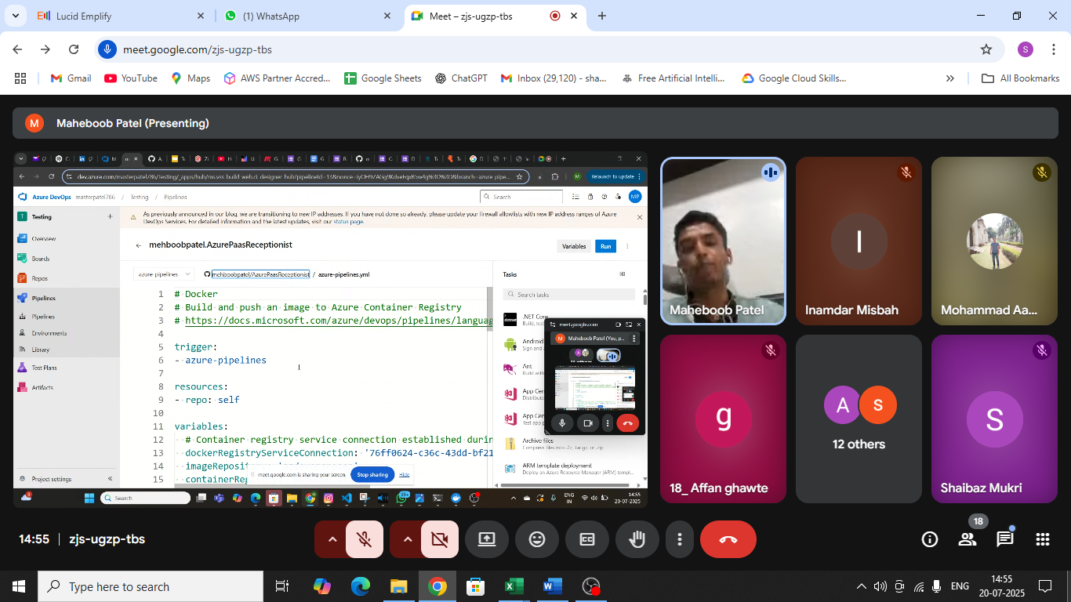

abhishek veeramalla

code with naina

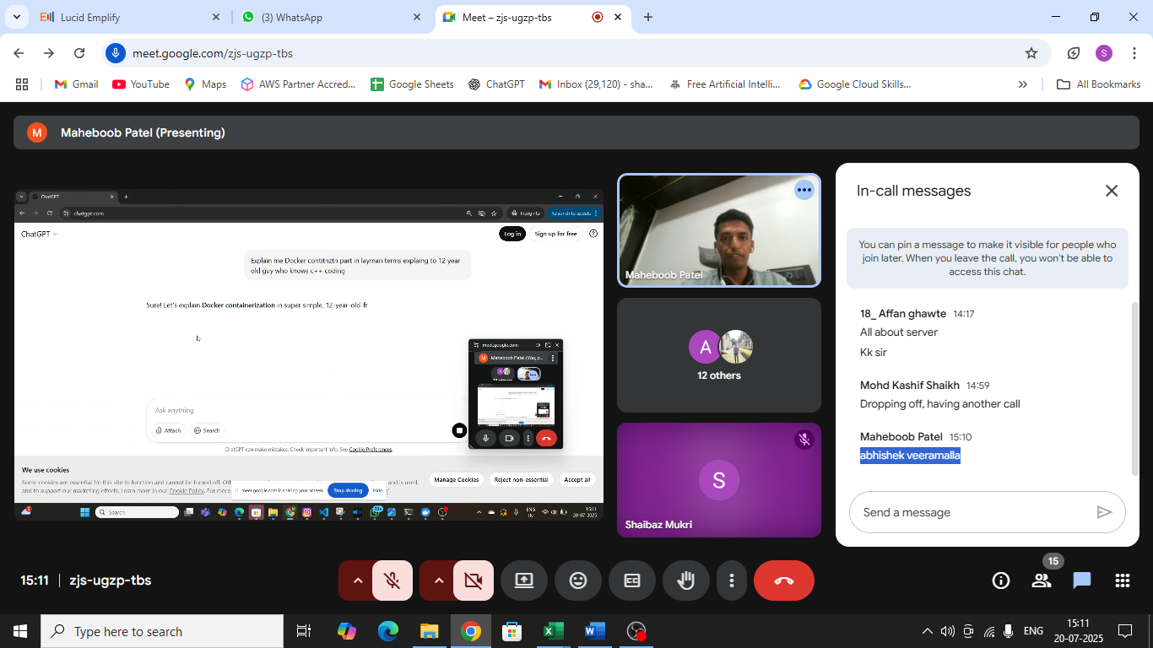

Wsa

Linux op sys

Kubernetes based on docker based on linux

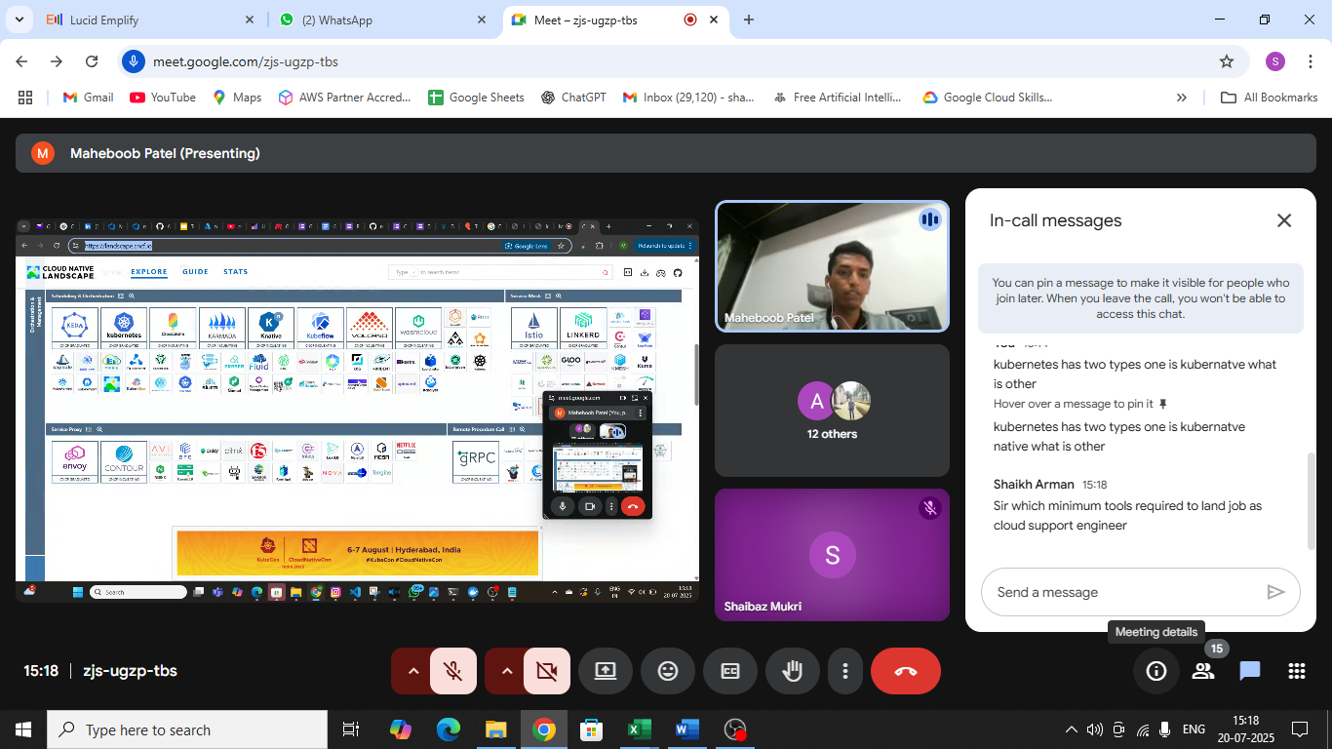

[https://landscape.cncf.io/https://landscape.cncf.io/](https://landscape.cncf.io/)